DESC branch

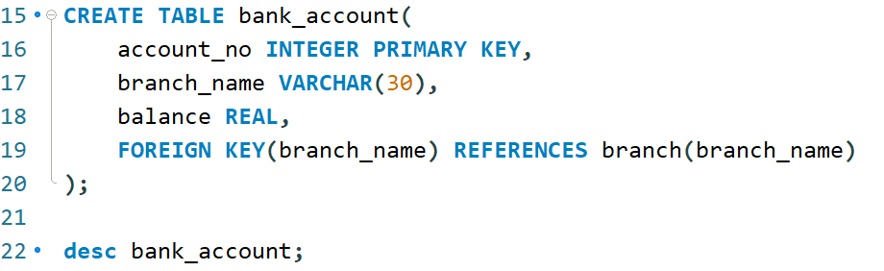

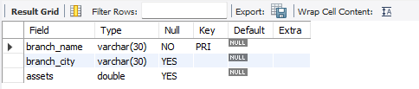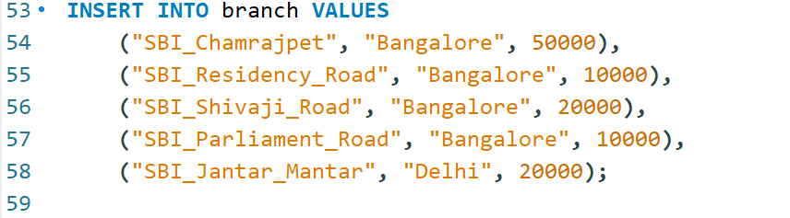

DESC bank_account

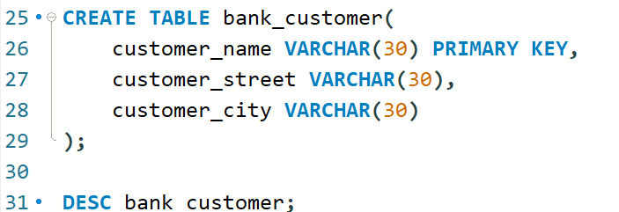

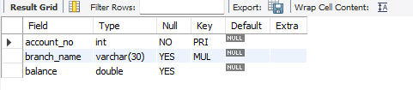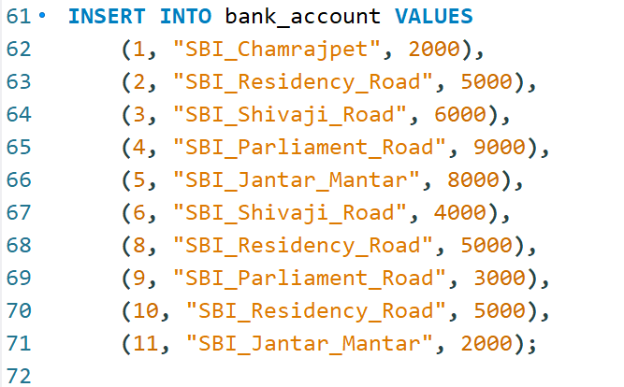

DESC bank_customer

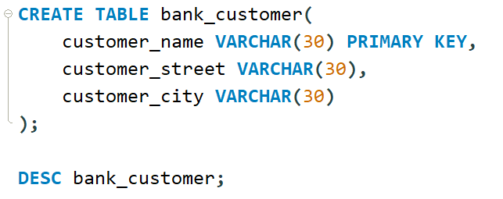

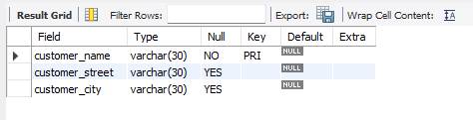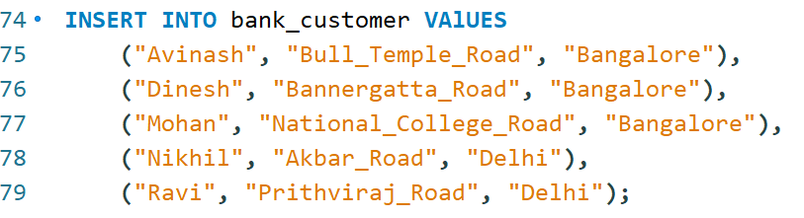

DESC depositor

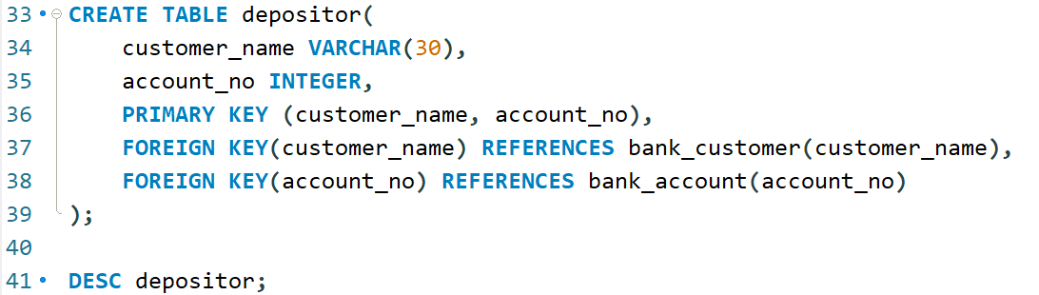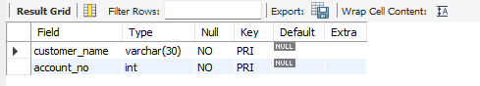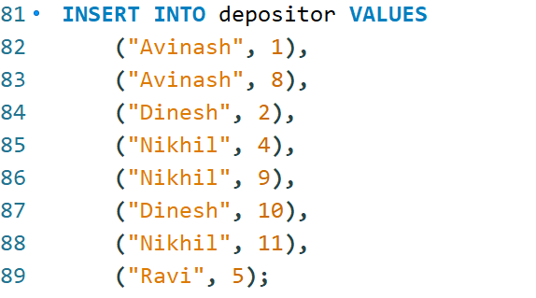

DESC loan;

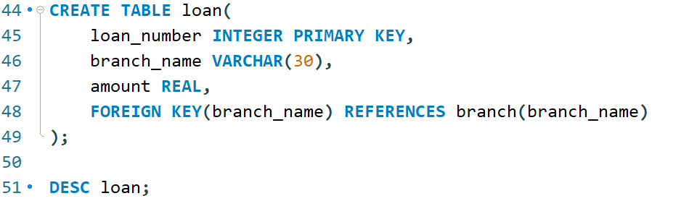

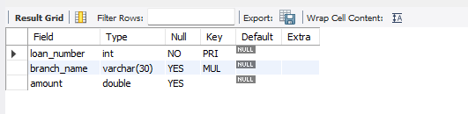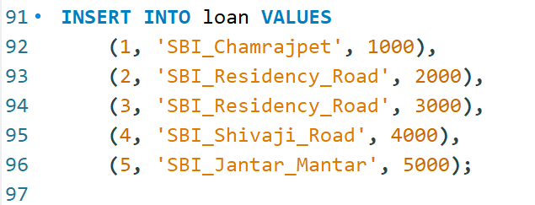

**Find all the customers who have atleast two deposits at the same branch**

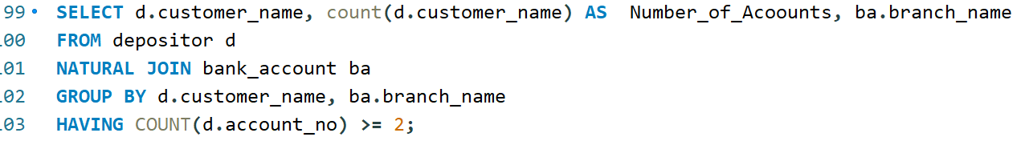

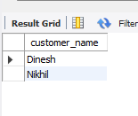

**Find all the customers who have an account at all the branches located in specific city ex: Delhi**

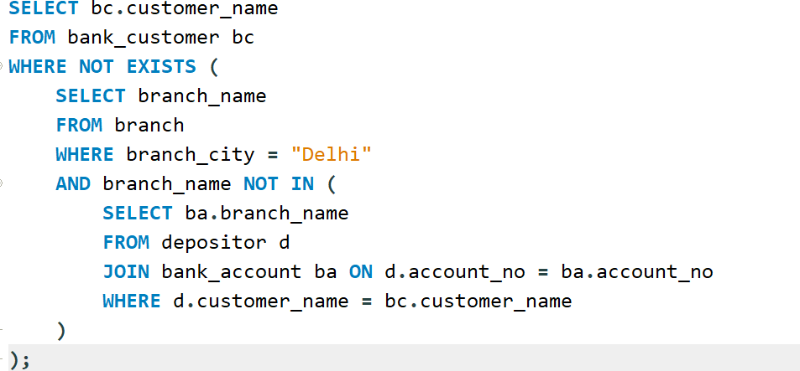

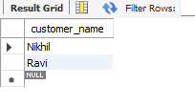

Demonstrate how you delete all the account tuples at a branch located at ex: Shivaji Road

